**Manually** start and shut down in this doc, but it can be set up as a windows service.

**Start:**

(1)

-> cd C:\Program Files (x86)\Cntlm

-> cntlm.exe -v -c cntlm.ini

(2)

-> cd C:\Program Files (x86)\JetBrains\IntelliJ IDEA Community Edition 14.1.5\bin

-> idea.exe

**Shut down:**

1. Kill the running job on Intellij of the jar file like

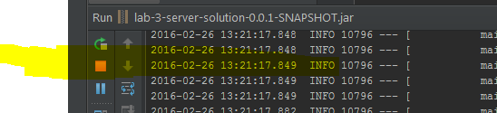

1. Use “Process Explorer” or other tools to kill cntlm.exe as shown below-> right click and kill or restart.

